Computer Programming  
Lab Tasks



Department of Computer Science - BUIC

Name: Saad Ahmad

Enrollment Number: 01-134222-130

**Exercises/Lab Journal 4**

**Task 0: Dry-run the following code snippet:**

int i, j, sum = 10;

for (i = 0; i<5; i++)

{

if (i % 2)

{

for (j = 0; j <= 3; sum += j, j++);

}

else

{

for (j = 3; j>0; sum += j, j--);

}

cout << sum;

}

**Task 1** : Using a do-while loop write a program that asks user to enter a temperature in Fahrenheit and convert it into Celsius. The program should ask the user if he/she wants to perform another conversion. In case the user enters an ‘N’ the program should terminate. This is similar to one of the practice tasks you have done. [Hint : Formula for conversion is: C = 5/9 (F-32)]. First Draw the flow chart of this problem and then write code.

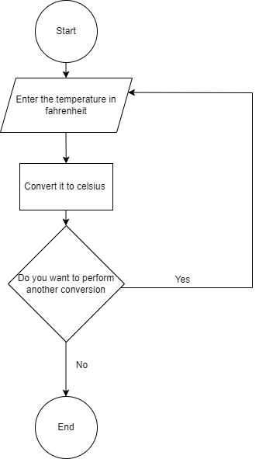

**Code :**

#include <iostream>

using namespace std;

int main()

{

jump :

int temp;

float c;

int i = 0;

char desc;

do {

cout << "Enter temperature in Fahrenheit" << endl;

cin >> temp;

c = (0.5555556) * (temp - 32);

cout << c << endl;

jump2 :

cout << "Do you want to perform another conversion \n [Y/N]" << endl;

cin >> desc;

if (desc != 'Y' && desc != 'N')

{

cout << "You have entered an invalid character" << endl;

goto jump2;

}

else {

if (desc == 'Y') {

goto jump;

}

else if (desc == 'N') {

i--;

}

}

} while (i >= 0 );

return 0;

}

**Output:**

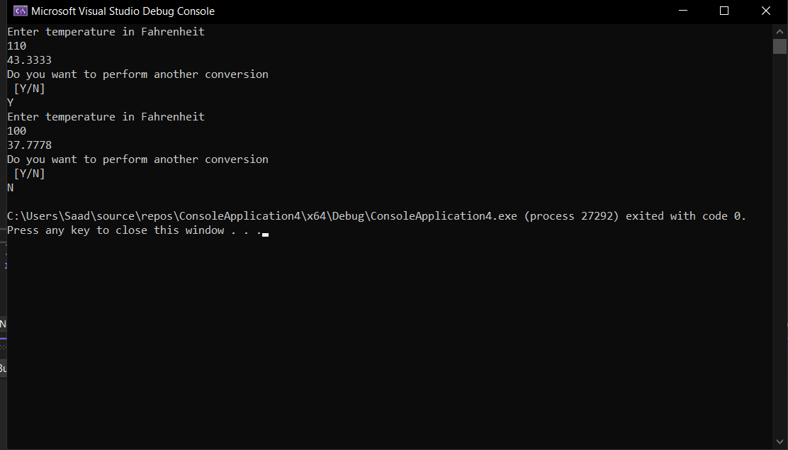

**Task 2:** Write a program to find the average of natural numbers from 1 to N using do while loop. Value of N should be entered by user.

[Hint : Average = sum of all numbers / total number of natural numbers]

1. Write pseudocode and then convert it into c++ program.

START

declare variable n

declare variable a

declare variable sum

declare variable avg

Print "Enter a number: "

Get a value for the variable n

Set a to n

set sum to zero

Do

set sum to sum plus n

compute n as n-1

Until (n is greater than or equal to one)

Print "Sum is:", print the value of sum

set avg to sum divided by a

Print "Average is: ", print the value of sum

END

**Code:**

#include <iostream>

using namespace std;

int main() {

int n;

int a;

float sum;

float avg;

cout << "Enter a number : " << endl;

cin >> n;

a = n;

sum = 0;

do {

sum = sum + n;

n--;

} while (n >=1);

cout << "Sum is : " << sum << endl;

avg = sum / a;

cout << "Average is : " << avg;

return 0;

}

**Output:**

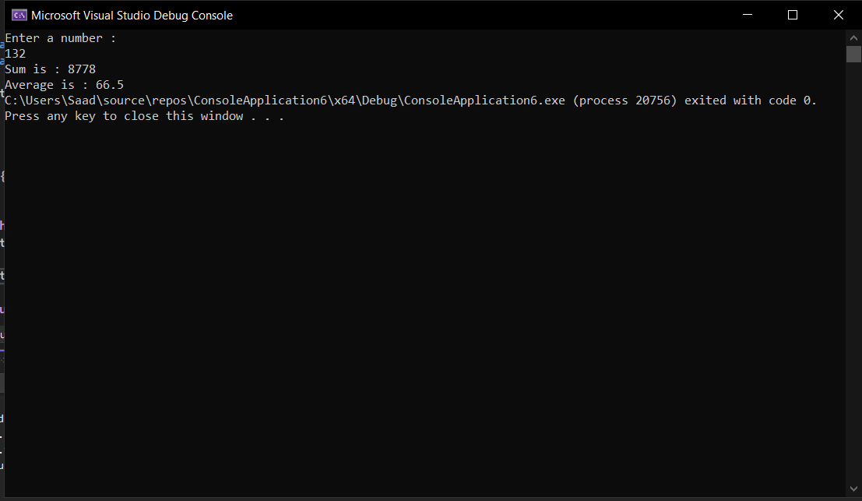

**Task 3:** Write a program that takes total number of students in a class. And then asks the user to enter marks for each student in the class and compute the class average. Use a while loop to compute the average. [Hint : Average = sum of marks of all students / total number of students]

**Code :**

#include <iostream>

using namespace std;

int main() {

int students;

int i=1;

int a;

int marks;

float sum=0;

float avg;

cout << "Enter the total number of students : ";

cin >> students;

a = students;

while (students >= i) {

cin >> marks;

sum = sum + marks;

students--;

}

avg = sum / a;

cout << avg;

return 0;

}

**Output:**

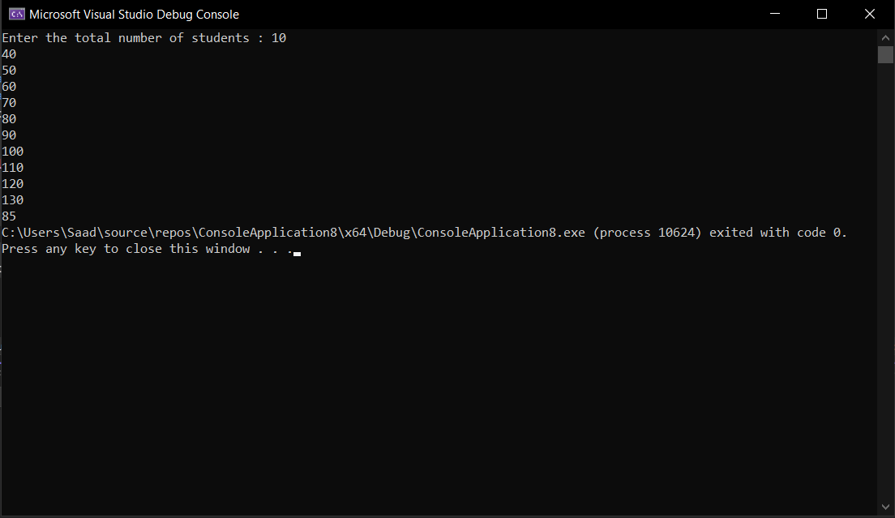

**Task 4:** Write a program to calculate the factorial of a number using while loop ((n! is factorial of n) n=3, n! =3*2*1*0!, 0!=1)

**Code:**

#include <iostream>

using namespace std;

int main() {

int num;

int sum = 1;

int i;

cout << "Enter a number to calculate its factorial : " << endl;

cin >> num;

i = num;

while (num >= 1) {

sum = sum * num;

num--;

}

cout << sum;

}

**Output:**

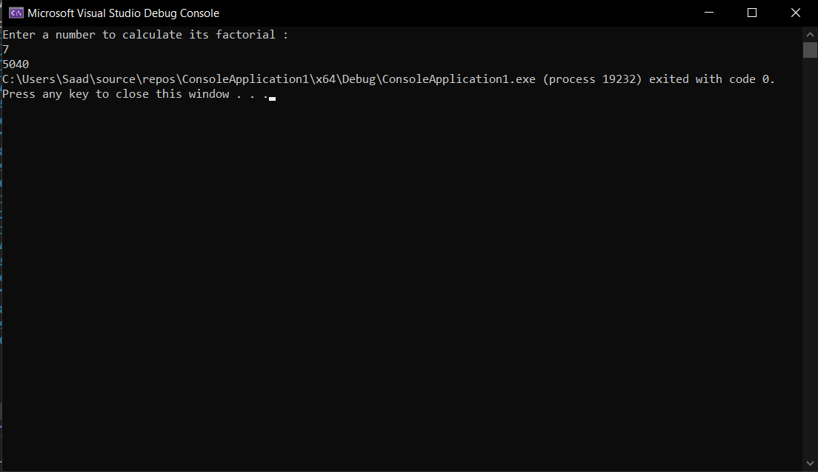

**Task 5:** Write a program that prompts the user to input a positive integer and then output both the individual digits of the number (in any order) and the sum of the digits. For example, suppose number = 1234567 then sum = 1+2+3+4+5+6+7=28.

**Code:**

#include <iostream>

using namespace std;

int main() {

int num;

int i;

int sum = 0;

cout << "Enter a number : " << endl;

cin >> num;

while(num != 0){

i = num % 10; // taking modulo of the number with 10 gives us the last digit of that number

cout << i << " + ";

num = num / 10; /* dividing the number by 10 turns the last digit into a decimal number

since the data type is an int so the compiler will ignore it*/

sum = sum + i;

}

cout << " = " << sum;

return 0;

}

**Output:**

